1

Hello everyone, I’m Michael Davis. I’m a rising second year grad student at the University of Minnesota with Michael Coughlin. This summer at Los Alamos I worked on a classifier to find kilonovae in the ZTF database.

2

The main goal is to find kilonovae within the ZTF database

A difficult part of the classifier is discriminating between GRB afterglows, supernovae, and other events that can be confused for a kilonova. It is also very important not to get false detections, so it must have a very high accuracy rate.

This was all done by using NMMA for analyzing the ZTF transients

3



I will first introduce ZTF.

4

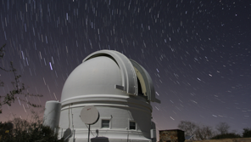

The Zwicky Transient Facility is an extremely wide-field of view camera installed on the 1.2 meter telescope at the Palomar Observatory outside of San Diego, California.

5

The amazing thing about ZTF is its wide field of view of 47 square degrees. On the right is ZTF’s view compared to:

* DES = Dark Energy Survey
* SDSS = Sloan Digital Sky Survey
* PS1 = Pan-STARRA (Panoramic Survey Telescope and Rapid Response System)
* PTF = Palomar Transient Factory (succeeded by ZTF)
* LSST = Rubin Observatory

It has a 20.4 magnitude depth in the g, r, and i bands with a 30 second exposure.

The most impressive part of ZTF is its survey rate. It can survey the entire northern sky in about 2 nights. This makes it the perfect tool to observe transients as it can see any change immediately instead of taking weeks.

6

ZTF uses the site Fritz as its data platform

7

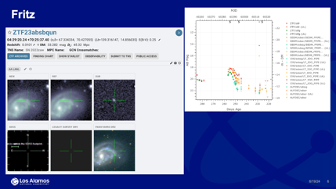

It allows you to see the new image, as well as the reference image, and any other available images. It provides photometry and spectroscopy, and an alert system.

8

I used the Bayes factor this summer. The Bayes factor is used to compare two competing hypotheses or models by using the evidence to favor one model over another

BF compares different models based on the same dataset

Evidence (marginal likelihood) is the total probability of observing the data under a particular model. Calculated by integrating the likelihood over all possible values of the model parameters, weighted by their prior probabilities. It emphasizes the overall fit of the model to the data

9

And this is the interpretation of the log of the Bayes factor. So we’re looking for values larger than 5 or 10 to indicate that a model is strongly favored

10

These are the models I have used to analyze ZTF transients. I put the transient and the model through NMMA to determine if the model fits the data accurately. The models are for **kilonovae**, **supernovae**, **shock** **breakouts** (occurs when the shock wave generated by the core-collapse of a massive star or by a thermonuclear explosion in type Ia’s, breaks out through the outer layers of the star), and **GRB** **afterglows** (the emission that follows the initial burst of gamma rays in a GRB, lasting from days to years).

One of the main points of this project was to also compare LANL Kilonova models, but unfortunately, I’m having problems running the analysis of them due to formatting issues. My main future goal is to get those working, as it was why I was doing this project at LANL in the first place.

11



This project is still very much in progress, but next I’ll show my current results

I have been analyzing about 180 transients in preparation for creating the classifier. I will show a single transient and go through the process.

12

This is a transient from a few months ago. This shows a very clean peak with data going out to about 35 days after the peak

13

Only analyzes out to 14 days, when the transient was up to 35 days. Currently looking into differences

My next step was to run the transient against my models using NMMA’s light curve analysis. Top left model is shock breakout, bottom left is supernovae, and right is kilonovae

Observed data points: The points with error bars represent the actual observational data in various filters (ztfg, ztfr, and ztfi).

**Model Prediction**: The dashed line shows the model's predicted light curve, with the shaded region representing the uncertainty in the model's predictions.

**Residuals** are the differences between the observed data points and the values predicted by the model. In this context, they show how much the model's prediction deviates from the actual observed data at each time point. If the points are close to the dashed line at 0, the model fits the data well. Ideally, the residuals should scatter randomly around 0, without any systematic pattern. If the residuals consistently deviate in one direction, it suggests that the model might be systematically biased or missing something.

Chi-squared: This value (shown at the top of each plot) gives a quantitative measure of how well the model fits the data. Lower values indicate a better fit.

• **ztfg χ²/d.o.f. = 0.07**: This is an excellent fit, indicating that the model closely matches the data in this filter.

• **ztfr χ²/d.o.f. = 0.25**: Also a good fit, but slightly worse than the first filter.

• **ztfi χ²/d.o.f. = 19.41**: This is a poor fit, meaning the model does not match the data well in this filter.

• The model with the consistently lowest χ²/d.o.f. across all filters is likely to be the best fit for this transient.

• Since this transient is a type IIb supernova, you'd expect the supernova model to fit best, while the kilonova and shock breakout models might not fit as well.

14

• **Marginal Distributions (Diagonals)**: Look at these to understand the range and most probable values of each parameter. Likely values based on the model

• **Joint Distributions (Off-Diagonals)**: Examine these to see how two parameters influence each other. For example, if two parameters are strongly correlated, this could imply that changes in one parameter necessitate changes in another to maintain a good fit with the data.

• **Degeneracies**: If two parameters are strongly correlated, it might indicate a degeneracy where different combinations of those parameters produce similar fits to the data.

• **Model Testing**: The corner plot can help you see if your model's predictions align well with the observed data. If certain parameters are poorly constrained or highly correlated, it might suggest that the model is not fully capturing the underlying physics or that the data isn’t sufficient to constrain all parameters well.

• **Highly Correlated**: Imagine a narrow, diagonal ellipse. This indicates a strong correlation, where knowing the value of one parameter gives you a lot of information about the other.

• **Moderately Correlated**: A broader, less tilted ellipse suggests moderate correlation. There’s some relationship, but it’s not as strong.

• **Uncorrelated**: A circular contour suggests that the parameters vary independently of each other.

• **Correlated Parameters**: If parameters are highly correlated, this might mean that there is a degeneracy in the model—different combinations of parameters could give similar fits to the data. In such cases, you might need more data or different kinds of data to break the degeneracy.

• **Uncorrelated Parameters**: Uncorrelated parameters suggest that they can be varied independently without affecting the model's fit. This is generally a good sign that the parameters are well constrained by the data.

15

There’s a lot going on in this slide. This looks at the Bayes factor for this transient. So the if you recall this equation. The x axis is Model 1, the y axis is Model 2. The diagonal will be zero because it’s applying the same model to itself, and the matrix is anti-symmetric as opposite sides of the diagonal are opposite signs

Looking at these Bayes factors, none really stand out as decisive evidence. There’s a few 4’s or 5’s favoring one Kilonova model or another. But not very conclusive evidence just by looking at this.

Bayes factor of zero shows that evidence for both models is equally strong (neither is favored), so it’s always inconclusive on the GRB afterglow

Now to classify this transient. The light curve alone makes this look somewhat straightforward, but the Bayes factors don’t specifically favor any model decisively

16

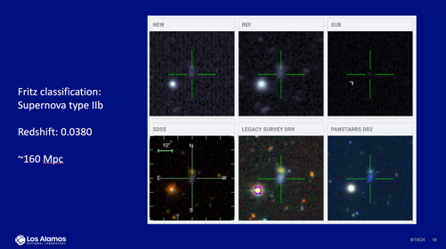

This transient is quite confidently a Type IIb supernova (core collapse with fading hydrogen lines)

A redshift of 0.0380 or about 160 Mpc

17

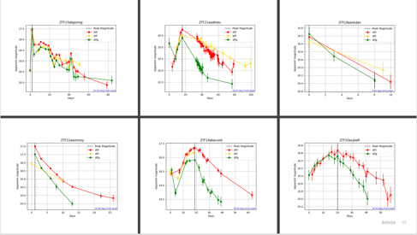

And just to demonstrate how each light curve can look, there’s a lot of variation in possibilities, and most of these are among the cleaner curves.

18

There is still much more to be done, like actually confidently getting the classifier going. I also want to find some consistent threshold for identifying a kilonova

My main goal right now is to get the LANL models working as that was one of the main points of this project, to compare the types of models to see if there is any specific model that gives a higher confidence

I would also like to try different samplers to again test confidence and compare Bayes factors

This week I have also started injecting controlled transients to see how they are identified. I’m very interested to see when something will be flagged and what parameters can cause it to correctly or incorrectly identify a transient

Thank you for your time, and I’m happy to take any questions